**Weekly Status Report - 2019-Mar-28**

|  |  |
| --- | --- |
| **Project Name** | ThinkFood |
| **Team Lead** | Quang Pham |

|  |  |  |  |  |  |
| --- | --- | --- | --- | --- | --- |
| **Roles** |  |  |  |  |  |
| **Week** | **ChangSin Park** | **Qi Li** | **Rolando Pacho** | **Quang Pham** | **Jonghyun Choi** |
| 02 | DBA/Back-End developer | Front-End developer | Middle-ware developer | Front-End developer | Team Lead  Technical Writer |
| 03 | DBA/Back-End developer | Team Lead  Front-End developer | Middle-ware developer | Front-End developer | Technical Writer  DBA/Back-End developer |
| 04 | Front-End developer | DBA/Back-End developer | Team Lead  Front-End developer | Middle-ware developer | Technical Writer  DBA/Back-End developer |
| 05 | Team Lead  Middle-ware developer | DBA/Back-End developer | Technical Writer  Front-End developer | Front-End developer | Middle-ware developer |
| 06 | DBA/Back-End developer | DBA/Back-End developer  Technical Writer | Front-End developer | Team Lead  Front-End developer | Middle-ware developer |
| 07 | Front-End developer | Middle-ware developer | DBA/Back-End developer  Technical Writer | DBA/Back-End developer | Team Lead  Front-End developer |
|  |  |  |  |  |  |

|  |
| --- |
| **Weekly Project Summary** |
| * Modify cart list * Check out product * Privacy agreement for the first log out * Display rate and review |

|  |  |  |  |  |  |
| --- | --- | --- | --- | --- | --- |
| **Key Milestones Status** | | | | | |
| **ID** | **Description** | **Planned Completion** | **Forecasted**  **Completion** | **Actual Completion** | **Status** |
| 6 | Requirement is defined | 2019-03-06 | 2019-03-06 | 2019-03-07 | Closed |
| 22 | Preparation for development | 2019-03-18 | 2019-03-18 | 2019-03-18 | Closed |
| 52 | Completion of Implementation | 2019-04-03 | 2019-04-03 | - | In process |
| 57 | Ready for final presentation | 2019-04-10 | 2019-04-10 | - | - |
|  |  |  |  |  |  |

|  |
| --- |
| **Key Accomplishments for the Week** |
| * Complete modify cart * Complete check out process * Privacy agreement |

|  |  |  |  |
| --- | --- | --- | --- |
| **Task Assignments for the Coming Week** | | |  |
| **ID** | **Description** | **Assigned To** | **On Schedule** |
| 30 | Display product recommendation | Murphy | Yes |
| 52 | Customer Recommendation | Murphy | Yes |
| 55 | Test case | Changsin | Yes |
| 41 | Display order history | Rolando, Murphy | Yes |
|  |  |  |  |
|  |  |  |  |
|  |  |  |  |
|  |  |  |  |
|  |  |  |  |

|  |  |  |
| --- | --- | --- |
| **Tasks Completed in the Previous Week** | |  |
| **ID** | **Description** | **Assigned To** |
| 31 | Rate and review | Murphy |
| 35 | Remove product | Quang |
| 36 | Modify quantity | Quang |
| 38 | Billing/Shipping Form | Rolando |
| 39 | Validation | Rolando |
| 40 | Create a file for the receipt | Rolando |
| 42 | Privacy agreement | James |
| 55 | Test case | Changsin |

|  |  |
| --- | --- |
| Issues and Risks |  |
| **Description** | **Impact**  **(L,M,H)** |
|  |  |
|  |  |
|  |  |

|  |
| --- |
| **Gantt Chart** |

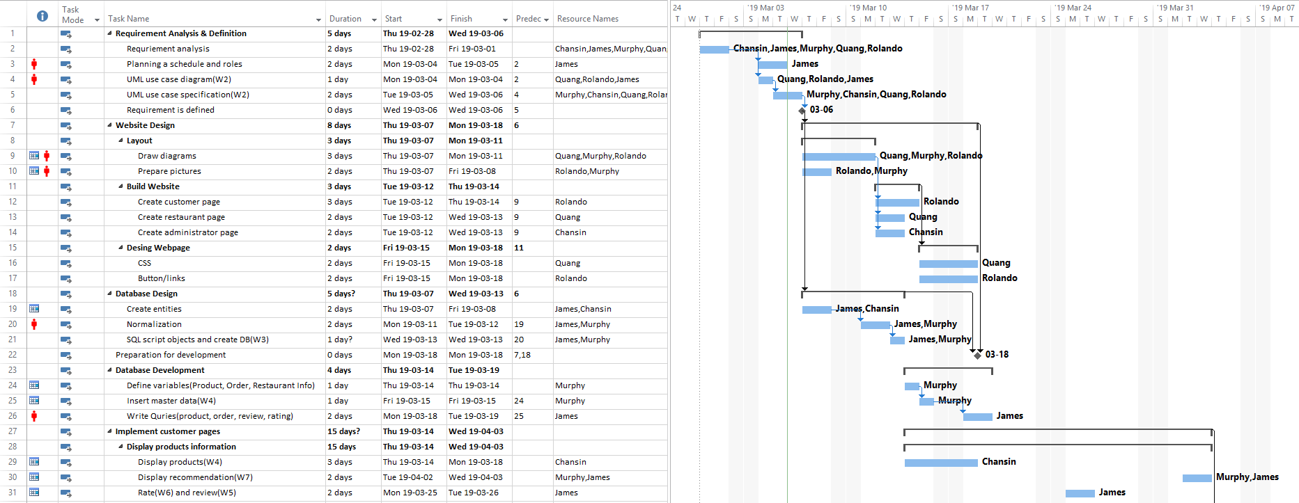

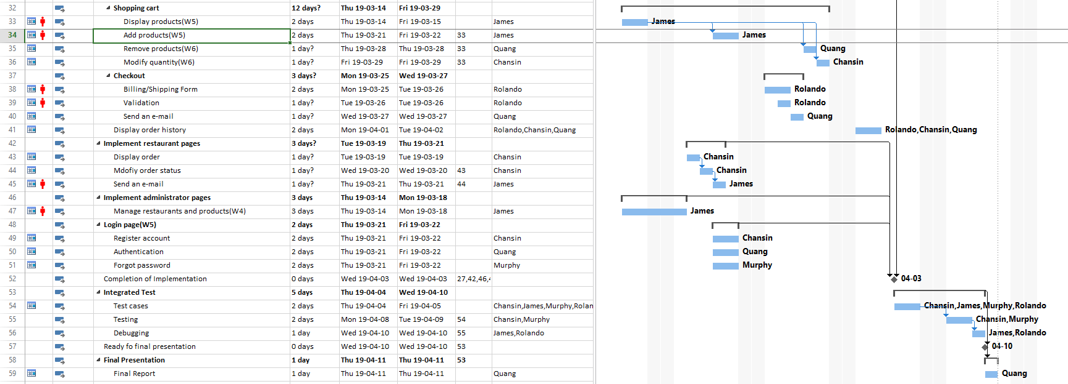*Git Log Report*

***Shopping-Cart Repo:***

ropacho: Merge remote branch 'origin'

ropacho: Added order history

dojun849: modified for register with agreement

dojun849: complete agree privacy term on header.php, privacy_temr.php

dojun849: commit for accept privacy term on login.php

dojun849: james test

dojun849: test james

ropacho: Merge remote branch 'origin'

ropacho: deleted some trash receipt

ropacho: added receipt number and time stamp

Jonghyun Choi: complete for agreement of privacy term

ropacho: price rounded to 2 and customer can now change shipping address

ropacho: Merging murphy's work

ropacho: Merge complete with quang works

ropacho: Merge branch 'rolando'

ropacho: delete

quanghuy25899: quang works

quanghuy25899: quang2

Ropacho: deleted lot of thing

Quang Pham: Delete customer_104_date_2019-03-31 17:24:33.txt

Quang Pham: Delete customer_104_date_2019-03-31 17:19:57.txt

ropacho: revert work

ropacho: customer reciept

ropacho: fixing merge conflict

Ropacho: merged quang work

Ropacho: Merge branch 'master' of https://gitlab.camosun.bc.ca/ics199-2019/group06/shopping-cart

quanghuy25899: quang works

quanghuy25899: quang works

Ropacho: Merge branch 'master' of https://gitlab.camosun.bc.ca/ics199-2019/group06/shopping-cart

ropacho: Merge branch 'master' into rolando

ropacho: fixed login and register bug

Ropacho: master comitting

Ropacho: Merge branch 'master' of https://gitlab.camosun.bc.ca/ics199-2019/group06/shopping-cart

ropacho: v2

ropacho: restaurant page done

Ropacho: Good

Ropacho: Merge branch 'master' of https://gitlab.camosun.bc.ca/ics199-2019/group06/shopping-cart

ropacho: Checkout complete v.2

ropacho: Checkout Complete

Ropacho: PULLING

ropacho: modified about us

ropacho: Checkout almost complete

ropacho: deleted weeklogs

Ropacho: Merge branch 'master' of https://gitlab.camosun.bc.ca/ics199-2019/group06/shopping-cart

Ropacho: commiting before the pull

ropacho: restaurant page

ropacho: Merge branch 'master' of https://gitlab.camosun.bc.ca/ics199-2019/group06/shopping-cart

dojun849: Correct for cartlist.php

ropacho: merged cartlist

ropacho: merging

dojun849: correct font size for cart

dojun849: fixing ttl amt for demo

Ropacho: fixed login

Ropacho: Ready for demo week 5

ropacho: Week 5 ready for demo

ropacho: Merge remote branch 'origin'

Ropacho: updating before merge

ropacho: merging

ropacho: fixing display products

***Test-project Repo:***

Changsin Park: Upload New File

QiLi: task log

QiLi: Delete Task_Log_for_2019-04-04-Qi_Li_.docx

QiLi: Replace Task_Log_for_2019-04-04-Qi_Li_.docx

QiLi: task log

Jonghyun Choi: Upload New File for task log

quanghuy25899: week 6

Changsin Park: Replace Weekly-Status-Report-for-2019-03-28.pdf

Changsin Park: Replace Weekly-Status-Report-for-2019-03-28.pdf

Jonghyun Choi: upload task log

Rolando: added my tasklog for week 5

quanghuy25899: task log for week 5

Changsin Park: Changsin's Task Log for week5

Changsin Park: Weekly Status Report week5